Project Report
Course: Introduction to Computing and Programming
Instructor: Adib Ahmed Anik
Department: General Education
Group Name: Segmentation Fault
Students Name:
- Fabiha Lamisa Simat (252023)
- Shainam Masud Manha (252011)
Submission Date: 12 August, 2026

Segmentation Fault: Student's Version

1. Abstract:
Segmentation Fault: Student's Version is a text-based interactive game developed in C using humorous situations from student life. Players make choices across eight events that affect statistics such as Mental Health, Energy, Money, GPA, Confusion, and Knowledge.
The title compares a student's brain “crashing” under academic pressure to a computer experiencing a segmentation fault. The project combines basic C programming concepts with creativity to create an interactive game.

2. Introduction:
The main objective was to apply the C concepts we learned by developing an interactive program. The game uses common student experiences and turns them into different choices and outcomes.
The game begins with a humorous System Check and continues through events involving assignments, classes, attendance, group work, and other student-life situations. It demonstrates how basic programming concepts can be used creatively.

3. Methodology / Implementation:
The game consists of eight events, each presenting three choices. Each choice produces a different outcome and modifies one or more player statistics.
Each event is implemented using a separate function. if, else if, and else statements handle choices, while pointers allow the functions to directly modify the player's statistics.
A final stats() function displays the accumulated statistics. Achievements and humorous messages were also included to make the game more engaging.

4. Tools and Technologies:
The project was developed using the C programming language and standard C libraries.
Main concepts used:
- Variables and data types
- Conditional statements
- Functions
- Character arrays
- Pointers
- Basic arithmetic and formatted output

5. Results / Output:
The game uses user input and conditional statements to create different outcomes. For each event, the player's choice is stored using scanf(). The program then checks the choice using if, else if, and else. The selected branch prints the corresponding messages and updates the player's statistics through pointers passed to the event functions. The following screenshots show each possible branch and its resulting output.

Event 1: AI Detector
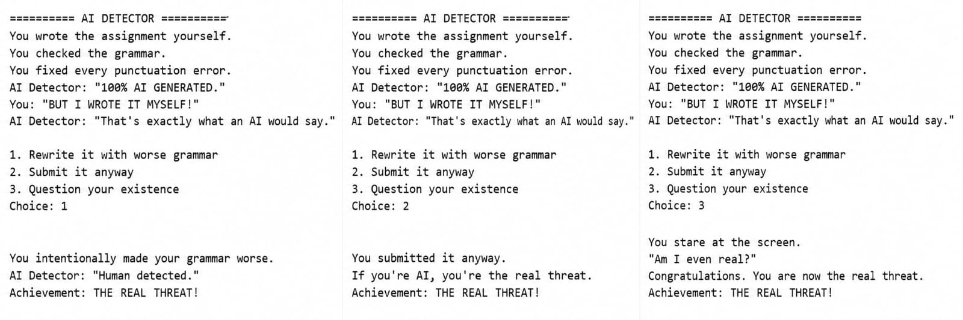
Choice 1 prints “Human detected.” (Mental Health +5, GPA −0.05, Confusion +15); Choice 2 prints “If you're AI, you're the real threat.” (Mental Health −10, Knowledge +5); Choice 3 prints the existential-crisis dialogue (Mental Health −20, Confusion +30).

Event 2: The Fake Understanding Nod
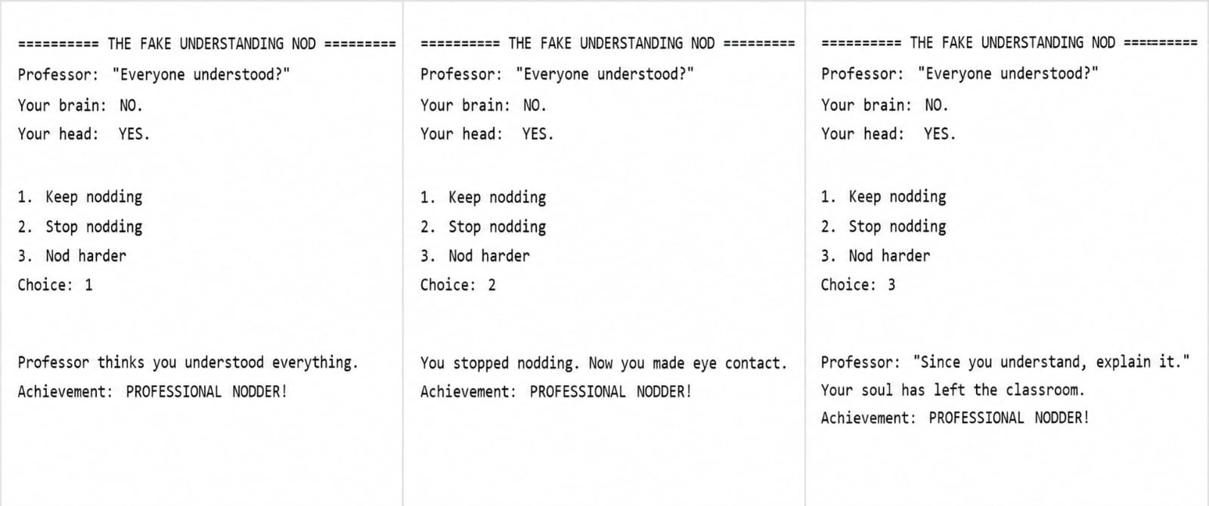
Choice 1 prints “Professor thinks you understood everything.” (Knowledge −5, Confusion +20); Choice 2 prints “You stopped nodding. Now you made eye contact.” (Mental Health −15); Choice 3 prints the professor's challenge and student's reaction (Mental Health −30, Confusion +40).

Event 3: Seat Dispute
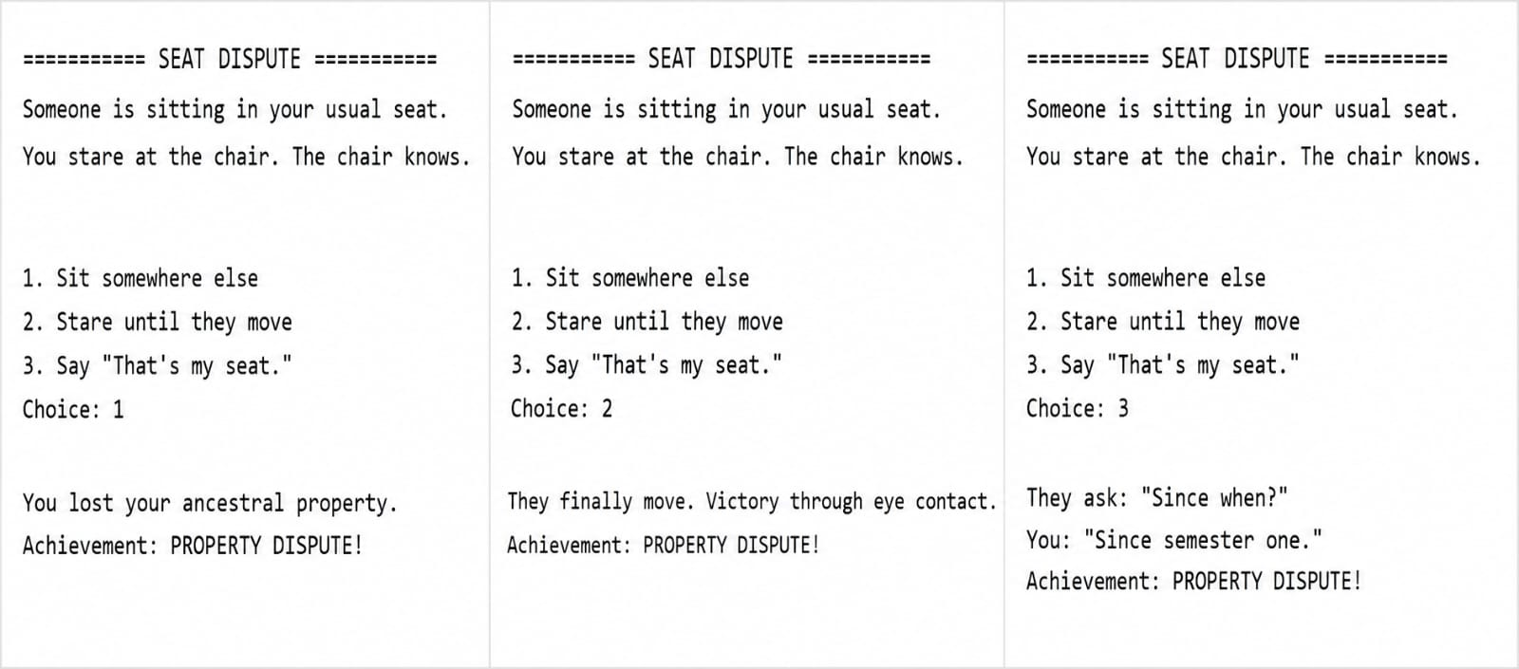
Choice 1 prints “You lost your ancestral property.” (Mental Health −15); Choice 2 prints the eye-contact victory message (Mental Health +5); Choice 3 prints the “Since semester one” conversation (Confusion +15).

Event 4: File Naming Disaster
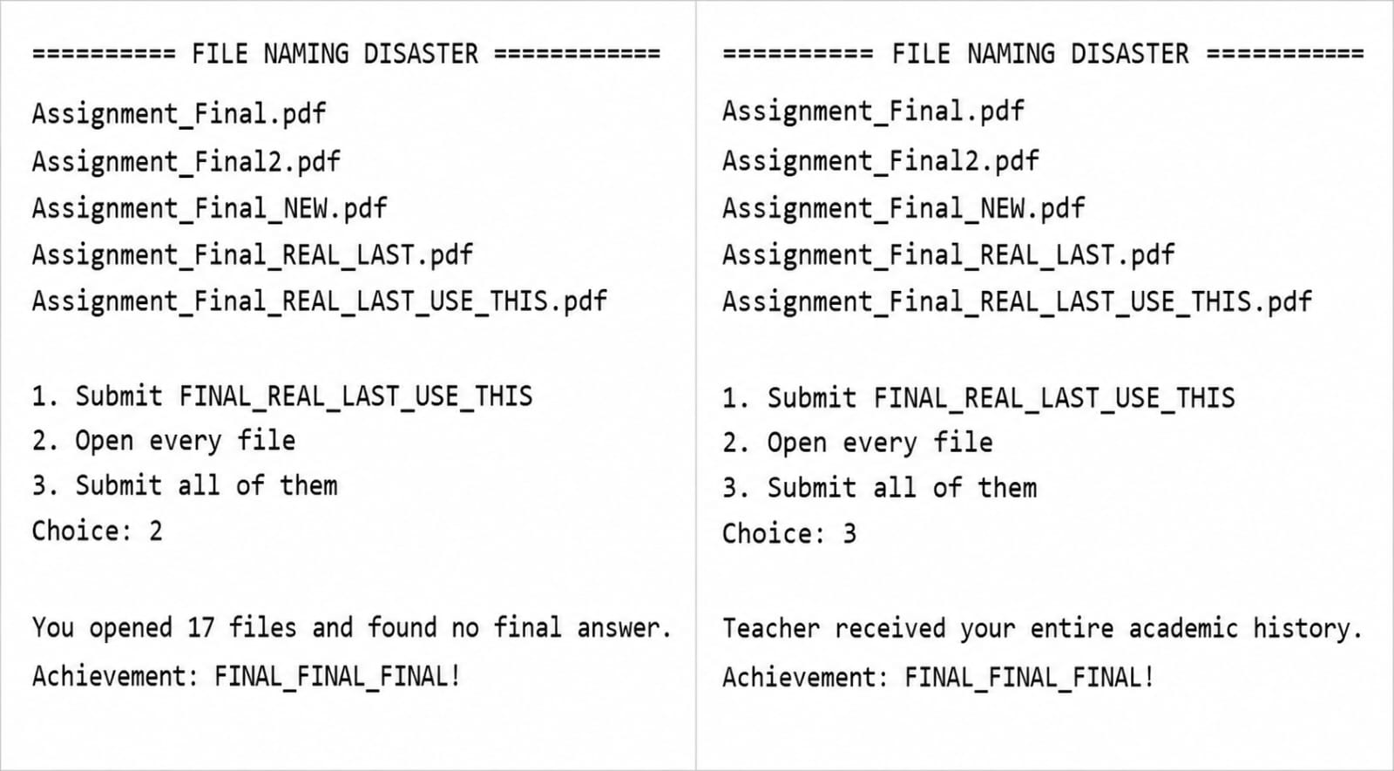
Choice 1 prints “You trusted the name. Brave.” (Mental Health +5); Choice 2 prints that 17 files were opened without finding the final answer (Energy −20, Confusion +15); Choice 3 prints that the teacher received the entire academic history (Mental Health −10, Confusion +25)
Event 5: Shared Document Mystery
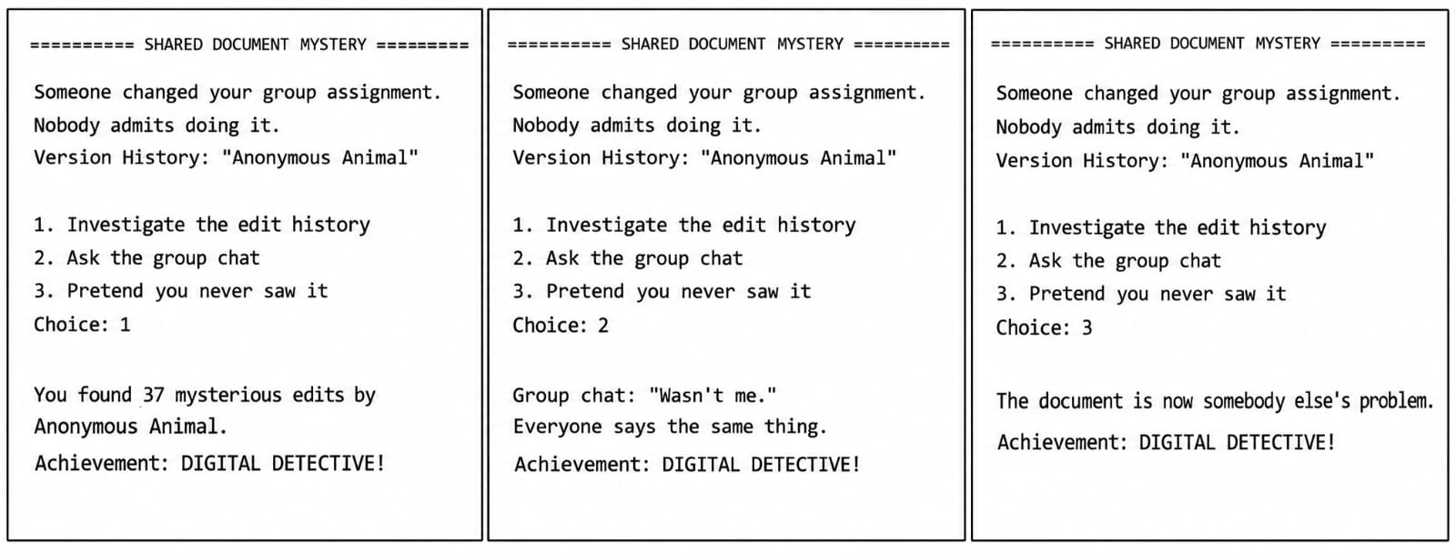
Choice 1 finds 37 mysterious edits (Knowledge +10, Confusion +15); Choice 2 gives the repeated “Wasn't me.” response (Mental Health −5, Confusion +20); Choice 3 makes the document somebody else's problem (Mental Health +5).

Event 6: The Human LMS
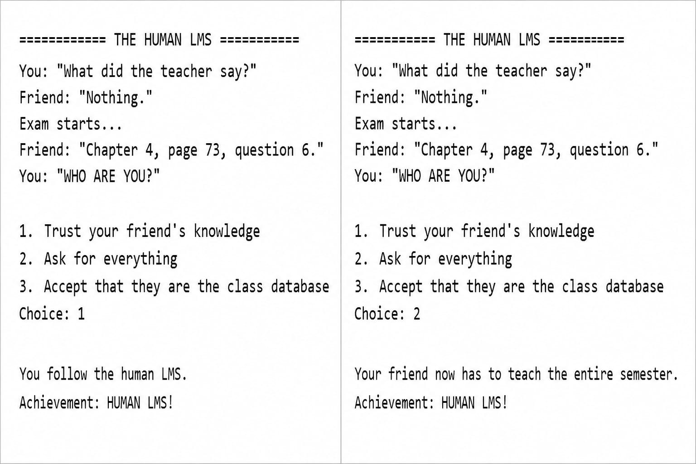

Choice 1 prints “You follow the human LMS.” (Knowledge +15); Choice 2 makes the friend teach the entire semester (Mental Health +5, Confusion +5); Choice 3 finds the “university database.” (Knowledge +10, Mental Health +10).

Event 7: Pen Exchange Economy
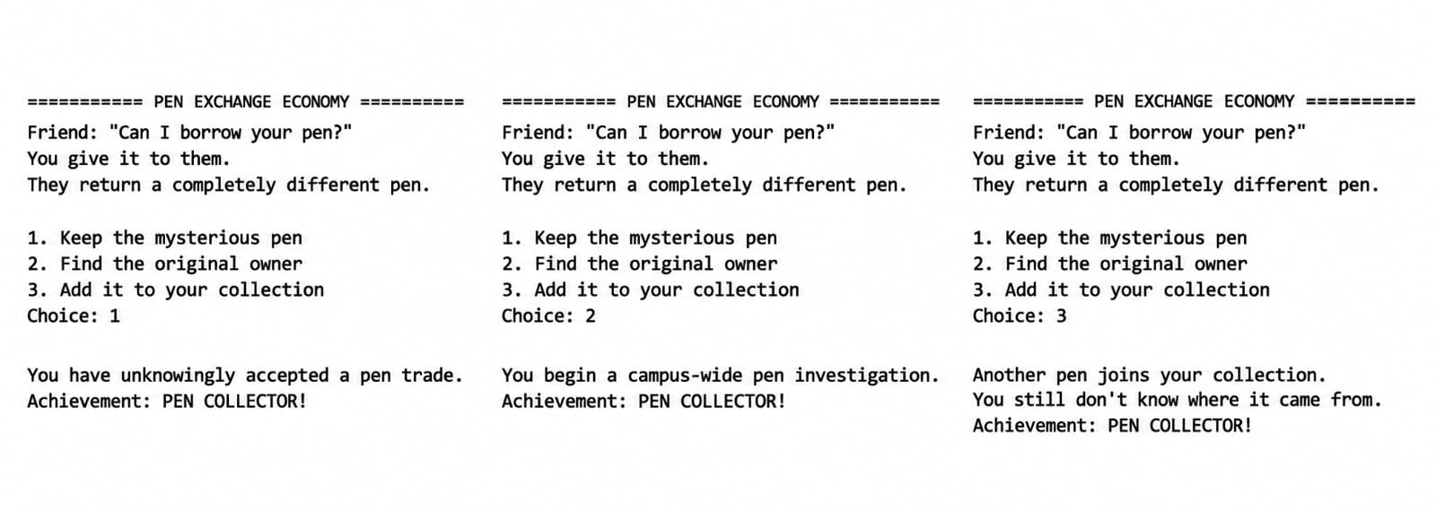
Choice 1 prints the pen-trade outcome (Money +5); Choice 2 starts the campus-wide search (Mental Health −5, Confusion +10); Choice 3 adds another pen to the collection (Mental Health +5, Confusion +5).

Event 8: Who Is Present?
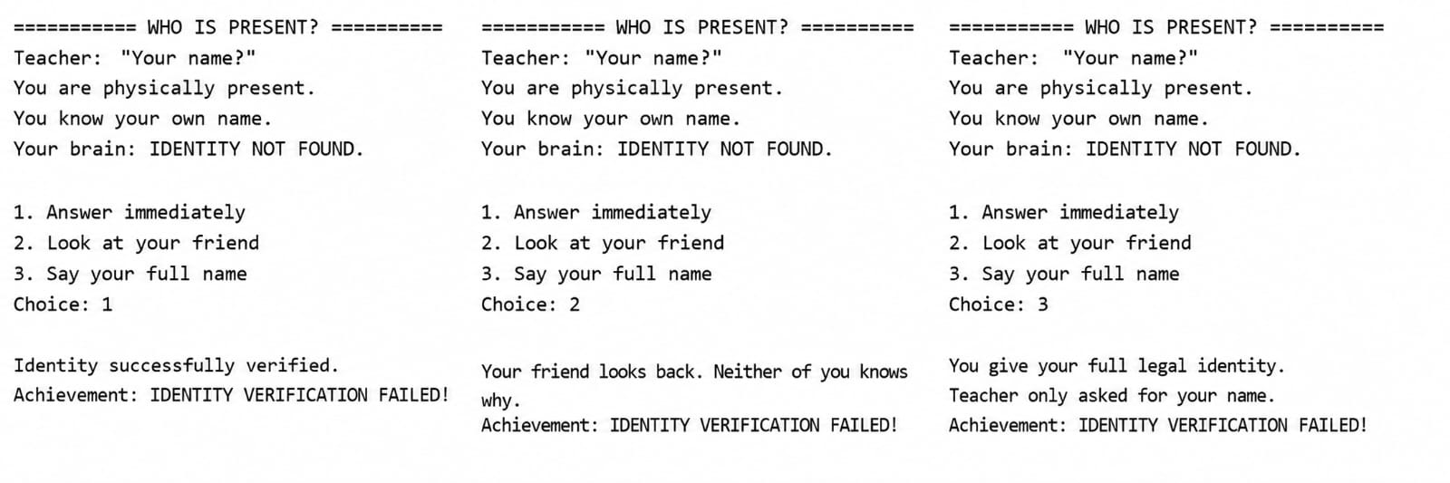
Choice 1 prints “Identity successfully verified.” (Mental Health +5); Choice 2 produces the mutual-confusion response during roll call (Confusion +10); Choice 3 gives the full legal identity and produces the attendance response (Mental Health −5).

6. Discussion:
The project demonstrated how different C concepts can work together in a larger program. User choices affect both dialogue and statistics, making the game interactive.
It also showed how programming concepts can be combined with creativity and familiar student experiences to develop an original project.

7. Challenges and Limitations:
Debugging was one of the main challenges. As the program grew, errors involving indentation, brackets, functions, and statistics had to be identified and fixed through repeated testing.
The current version has a fixed event sequence, basic input handling, and no saved progress or complex endings. The final segmentation fault is simulated through printed output rather than being an actual crash.

8. Conclusion:
Segmentation Fault: Student's Version allowed us to apply C programming concepts to a creative and relatable project. It combines choices, statistics, humor, and student-life situations into an interactive game.
The project provided practical experience with functions, conditional logic, pointers, debugging, and organizing a larger C program while showing how creativity can be incorporated into programming.

9. Future Work:
Future versions could include:
- More student-life events
- Multiple endings based on statistics
- Better input validation
- Save and restart option
- More achievements
- Improved interactivity
These features can be explored as we learn more advanced programming techniques.

10. References:
CS50 C Programming Materials
CS50 Arrays and Strings

